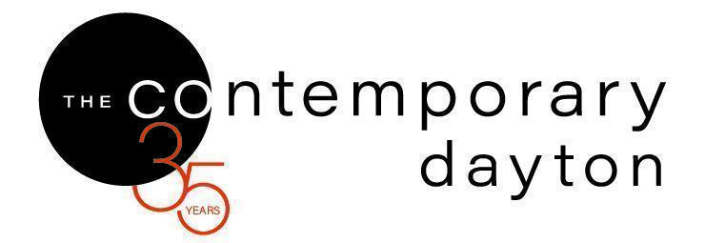
MEDIA CONTACT
Eva Buttacavoli, Executive Director
eva@codayton.org
937/224.3822
https://codayton.org/about-the-co/media-center-access/
Password: thecomedia3822

The Contemporary Dayton Presents
Niki Johnson: Pillars of Democracy
July 1-August 15, 2026

DAYTON (June 2, 2026) – The Contemporary Dayton is proud to present Niki Johnson: Pillars of Democracy, an exhibition by Milwaukee-based artist Niki Johnson exploring civic participation, collective action, and the enduring power of the vote. The exhibition opens Wednesday, July 1, 2026, with a public reception from 6–8 pm and an artist talk at 6:30 pm.
Pillars of Democracy is a monumental series of four collaged portraits envisioning Liberty, Justice, Freedom, and Forward progress as first-time voters from Milwaukee. Collaged out of discarded stencil paper and leftover spray paint from the 2020 installation of Shepard Fairey’s Voting Rights Are Human Rights mural, and and formally inspired by Bertha Boyd’s 1911 suffrage poster Votes for Women, this series unites more than a century of voting rights art activism in both material and design. It foregrounds the central role of women in the democratic process– from early suffragists to first-time voters today, uniting generations through civic participation and creative resistance.
Built over ten months with contributions from eight Milwaukee artists and the help of nearly seventy volunteers, Pillars of Democracy emphasizes that democracy is not abstract, but something actively shaped through everyday acts of participation, dialogue, and collective care.
“As we celebrate The Contemporary Dayton’s 35th anniversary season, this exhibition reminds us that democracy and freedom of expression are deeply connected,” said Heather Jones, Curator and Director of Programs and Engagement. “Artists create space for dialogue, reflection, and civic imagination, and Pillars of Democracy demonstrates how art can bring communities together while encouraging active participation in shaping the future.”
In conjunction with the exhibition, The Contemporary Dayton will present a series of free public programs designed to deepen community engagement. On Saturday, August 1, from 1–3 pm, Johnson will lead a hands-on collage-making workshop for up to 35 participants. Attendees will collaboratively create elements for a future public art project while exploring themes of community-building and creative expression.
A closing reception celebrating the exhibition will take place on Saturday, August 15, from 4–6 pm.
Merchandise related to Pillars of Democracy will also be available for purchase in the CoShop throughout the exhibition run. Proceeds will support the Pillars of Democracy: Unite & Rise tour, an initiative designed to engage audiences through exhibitions, artist talks, and workshops exploring the values that sustain a vibrant democracy. Aligned with the League of Women Voters national Unite & Rise campaign, the project highlights how artists, cultural organizations, and communities can work together to foster civic engagement and public dialogue.
Presented during The Contemporary Dayton’s 35th anniversary season, the exhibition reflects the organization’s ongoing commitment to freedom of expression, artistic inquiry, and civic dialogue. As Dayton’s contemporary art center, The Contemporary Dayton remains dedicated to providing free access to contemporary art and public programming for the community.
Johnson is a Milwaukee-based artist, curator, and Executive Director of the Forward Art Initiative. Her work is included in the collection of the Dayton Art Institute and has been reviewed in The New York Times, The Guardian, Hyperallergic, and Vice Magazine, among other national and international publications.

PUBLIC PROGRAMS & EVENTS / ALL PROGRAMS TAKE PLACE AT THE CONTEMPORARY DAYTON / FREE & OPEN TO ALL
Opening Reception
Wednesday, July 1, 2026, 6–8 pm
Artist talk at 6:30 pm
Free and open to all.
Community Workshop with Niki Johnson
Saturday, August 1, 2026, 2-4 pm
Designed for teens and adults, this interactive workshop invites participants to explore identity, voice, and civic engagement through art-making and conversation. Led by artist Niki Johnson, participants help in the creation of expressive artwork while reflecting on what democracy means to them and their role in shaping the future.
Free and open to all with registration.
Closing Reception
Saturday, August 15, 2026, 4-6 pm
Free and open to all.
SPONSORS:
Education & Public Programs: Dr. Robert L. Brandt, Jr.
Community Partners:
Artist Impact Working Group, Board of Trustees, Cross Street Partners, Hilton Garden Inn Dayton Downtown, The League of Women Voters of the Greater Dayton Area
SPECIAL THANKS TO OUR 2026-2027 OPERATING SUPPORT DONORS
Culture Works, The Dayton Foundation, The Montgomery County Arts & Cultural District, The National Endowment for the Arts, The Ohio Arts Council, The Virginia W. Kettering Foundation, and our Members.
GALLERY & CoSHOP HOURS
Wednesday–Saturday 11 am–6 pm
Closed Sunday-Tuesday
ALWAYS FREE & OPEN TO ALL
–––––––––––––––––––––––––––––––––––––

ABOUT THE CONTEMPORARY DAYTON
Advancing art for the community and a community for artists since 1991.

The Contemporary Dayton is the region’s contemporary art center. A 501(c)(3) nonprofit, The Contemporary Dayton produces and presents ART EXHIBITIONS, ARTIST TALKS, and PUBLIC ART by local, national, and global creatives and makers, and is ALWAYS FREE & OPEN TO ALL. As a non-collecting art center, The Contemporary Dayton is one of 45 non-collecting art centers and museums across North America that specialize in presenting modern and contemporary art.

###

